**553/2 BIOLOGY UCE**

1. You are provided with specimens P and Q which are animal and plant tissues respectively. Cut out 5 pieces from specimen Q each 1cm along. Put one of the pieces of Q in boiling water for 10 minutes crush one piece into a paste. Label 6 test tubes, 1,2,3,4,5 and 6. Put 3cm3 of hydrogen peroxide in each of test tubes 1,2,3,4 and 5. Put 3cm3 of distilled water in test tube 6.
2. Carry out the following tests on P and Q using solutions provided and record your observations and deductions in table 1 below

Table 1

|  |  |  |  |
| --- | --- | --- | --- |
| Tests | Observations | Deductions | Marks |
| 1. Test tube 1   + P (liver) | Very many; gas bubbles  Produced; /very fast effervescence  Reg –air bubbles. | Very fast rapid;  Decomposition of H2O2; | 02 |
| 1. Test tube 2   +Q (Irish potato) | Many; gas bubbles; /  Fast effervescence | Fast;  Decomposition of H2O2; | 02 |
| 1. Test tube 3   + crushed Q | Very many; gas bubbles;  Very fast effervescence | Very fast/rapid;  Decomposition of H2O2; | 02 |
| 1. Test tube 4   +Boiled Q | No; gas bubbles; /  Effervescence  Very few gas bubble | No;  Decomposition of H2O2;  Acc. Very slow decomposition | 02 |
| 1. Test tube 5   +HCL+Q | Few; gas bubbles; /  Slow effervescence. | Slow;  Decomposition of H2O2; | 02 |
| 1. Test tube 6   +Q | No; gas bubbles; /effervescence | No; decomposition of H2O/water;  Rej-H2O2 | 02 |

Explain the difference in results of test tube 1 and 2.

* Faster decomposition of H2O2 in test tube 1 then in test tube 2; therefore higher con centration of active ingredient in P than Q;
* This is because animals are more active that plants; leading to high production of wastes like H2O2; and therefore high concentration of active ingredient to decompose it to non toxic substances ; (04 marks)

1. Explain results in:
2. Test tube 3.

Crushing exposes many /more molecules of active ingredient in Q to H2O2/ substrate; and therefore very fast decomposition/very many bubbles; (01 marks)

1. Test tube 4.

Boiling denatures the active ingredient in Q; & therefore no decomposition of H2O2; (01 marks)

1. Test tube 6.

Water is not a substrate to the active ingredient in Q; therefore no decomposition/no gas bubbles. (01 marks

1. What properties of the active ingredient in P and Q were being investigated?

- denatured by boiling / high temperatures. (02 marks)

- works faster at high conc. of molecules

- Works slowly in acidic medium-Rej-if slowly is missing

- Works on specific substrate/specific in action.

(Any 2)

Total 21 Max 20 marks.

1. You are provided with specimens R and S which have been germinated for the same period of time.
2. With reference to the diagrams below measured and record the length of X and Y on the specimens in the table below (4 marks)

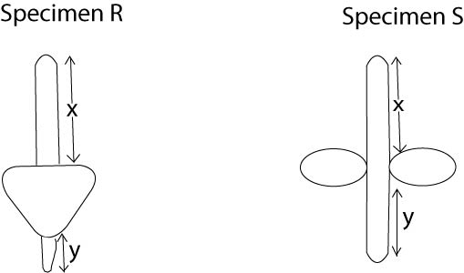

|  |  |  |
| --- | --- | --- |
| Specimen | R (Maize) | S (Bean) |
| Length of X | 3cm – 5cm | 0.5 – 2cm |
| Length of Y | 4cm – 6cm | 4cm – 8cm |

1. Compare the difference between X and Y in specimens R and S

R – X is longer; than Y/Y shorter than X;

S – X is much; shorter than Y/Y much longer; than X; (02 marks)

1. What is the importance of the difference in X and Y to the growth pattern of specimens R and S?

In R –X grows faster than Y / in increases in length faster y; leaving cotyledons under ground level;

In S-Y grows faster that X; pushing cotyledons above ground level; (owtte) (4 marks)

1. From your results name the type of germination shown by R and S.

(02 marks)

R: Hypogeal;

S: Epigeal;

NB – award marks for correct answers in (b),

(c) and (d) for any difference in X&Y that is bigger that in R; even when outside the range.

- deny marks if difference in R in bigger than in S

1. 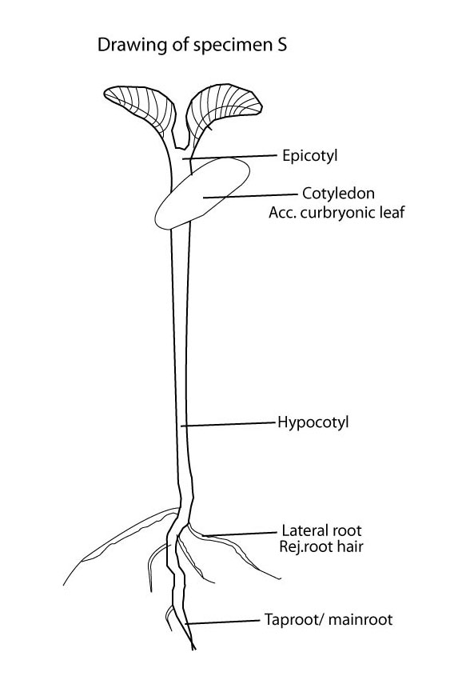Draw and label specimen S (08 marks)

Drawing points

T – 01 - Taproot - double line S&C/DS

M – 01 - Lateral root - double lines and closed.

N – 01 - Hypocotyl

O – 01 - Epicotyl

D – 02 () - Cotyledon

L – 02)

___________

08 (20 marks)

1. You are provided with specimens X, Y and Z which belong to the same phylum.
2. (i) Giving two reasons, state the phylum to which they belong. (3marks)

Phylum: Arthropoda; Rej: Anthropode/Arthropodia/anthropodia (01 mark)

**Reason.**

- Exoskeleton / hard outer cuticle/extended skeleton.

* Segmented body;
* Joined limbs/legs/appendages;

(Any two) (02 marks)

(ii) State the class to which the specimens belong. Give two reasons for your answer. (3marks)

Class:insectorRej-Insector/insecter /insects

Acc. Insect

(01 mark)

**Reasons.**

* Three pairs of legs
* Three main body parts/Head, thorax and Abdomen/3 major body parts/3 body divisions/3 thoracic segments. (02 marks)

1. Examine the specimens X and Y, using a hand lens where necessary, and explain **two** structural differences on the head.

Y has sharp/curved mandibles for defense/protection; while X- has a proboscis expanded at the tip for sucking liquid food;

- Y has no eyes; while X has large compound eyes for seeing; (04 marks)

1. (i) Describe the wings of Z.

- wings of Z

- has 2 pairs

- 1 pair of hard outer wings

- 1 pair of inner membranous wings

- has veins in wings /wings are veined

- Dull coloured wing (Any 2) (02 marks)

(ii) What are the structural adaptations of wings of Z to their functions?

* Have hard outer wings; for protection;
* Have membranous inner wings; for flexibility ;
* During flight Rej-for flying
* Have many veins; in wings for air circulation;
* Have many veins; for support;

(Any 2) (02 marks)

1. 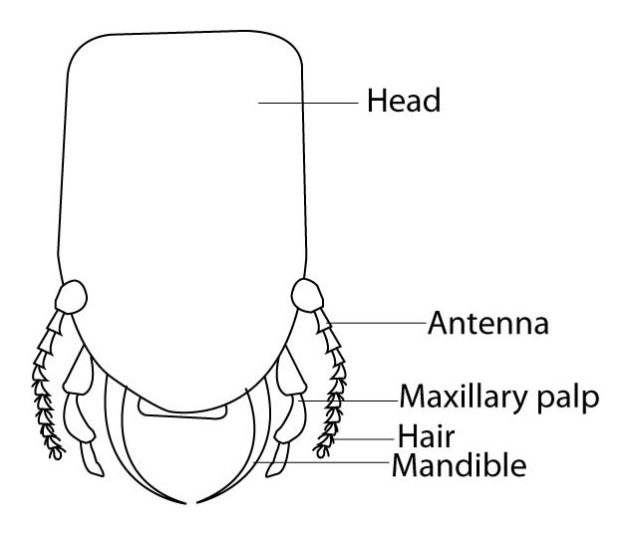Draw and Label the head of specimen Y. (06 marks)

M – 0 - Drawing points

T – 0 - head (tapering outeriory)

N – 0 - Antenna (Joined)

A - - Max palps (joined)

D - =02 - Mandible (curved tapering to the tip)

L - =02 - Hair (attached to palp)

___________

06 (total 20 marks)

**END**